Competitor Research – Top 3 Competitors
Here are key competitors for Cardekho in the online used car marketplace space:
- Cars24
- Spinny
- OLX Autos / OLX Motors
Unique Selling Points (USPs) for Cardekho
- Largest Variety of Listings
- Trusted Car Information & Reviews
- Easy Comparison Tools
- Smart Valuation Tools
- Secure Lead Generation
Campaign Setup
a) Selected Objective
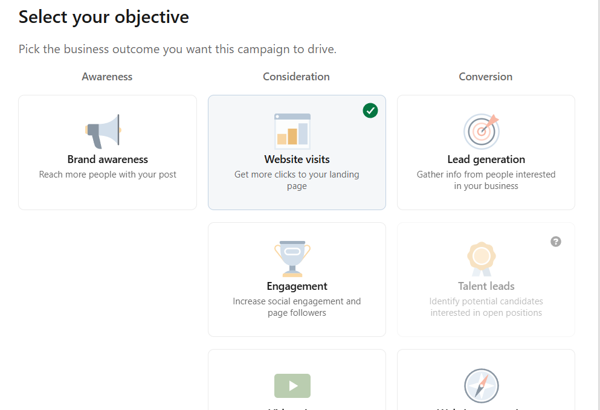b) Budget Setup
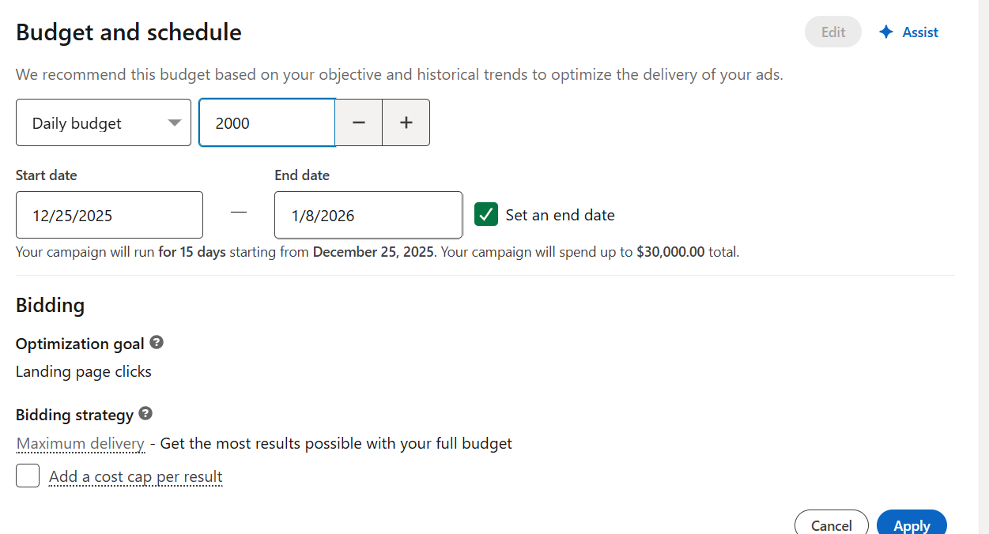c) Audience Targeting
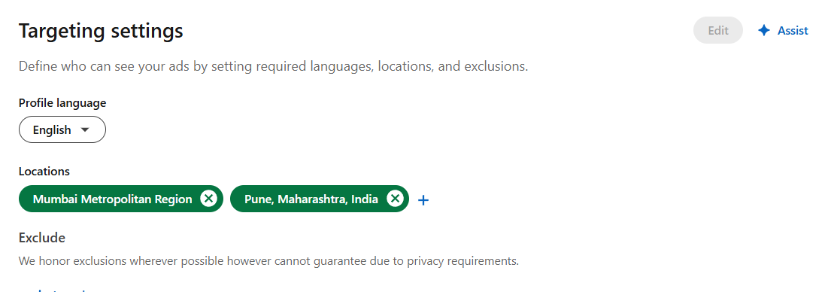
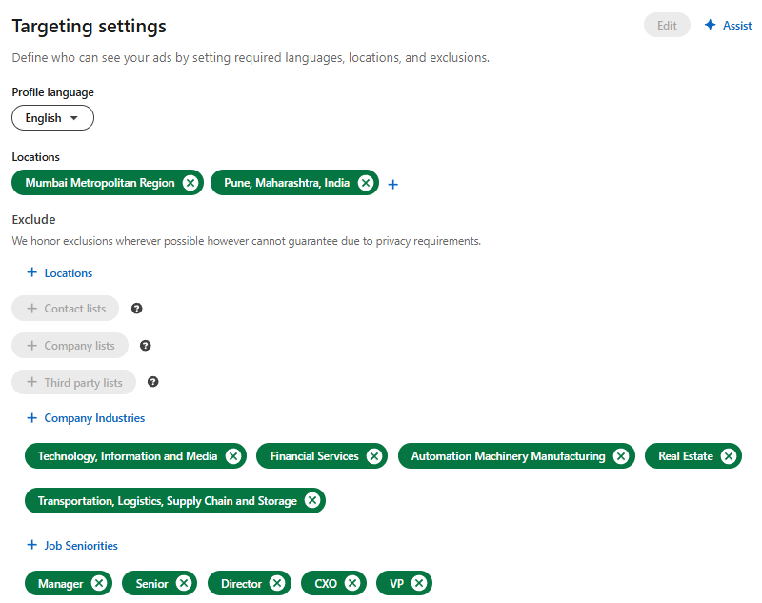
d) Ad Preview

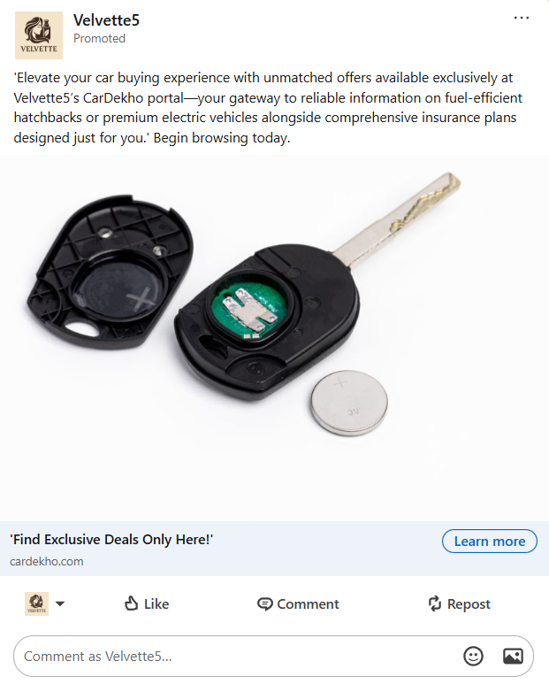
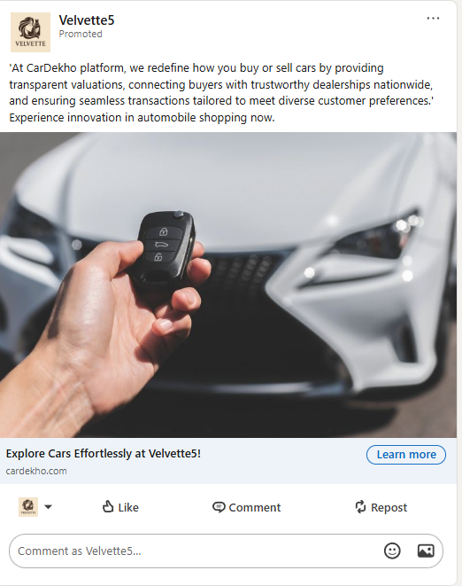


e) Estimated Campaign Results

